**C7 to C+7**

1. 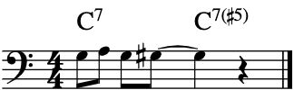
2. 